The steps below were realized after multiple attempts of trying to prove a theory or test doing a Physical Inventory Count. We don’t have a data collector device and direct scanning is an option but not very realistic.
Using a CSV file is the closest method to simulate a real business process and can be offered to clients as an option if they don’t have a “data collector” device.
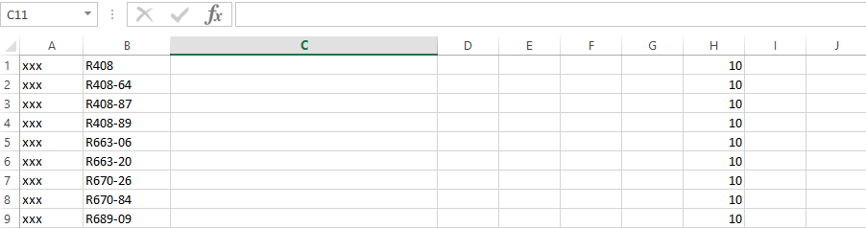
See the format and steps below.

FORMAT:
Part Number = Column B
Quantity = Column H

Notice that I have put “xxx” under Column A. Reason for that is that when we save the file into a CSV format, it pushes or move Column B over to Column A. To avoid that from happening, we just need to put contents under Column A.

Once you have the file saved as a CSV, you can now go and load it as a Scan Batch

Go To Inventory and Purchases / Physical Inventory Count
- Switch to “Scan Batch” tab and create a new count
- Set the “Scan Source” = Data Collector
- Build

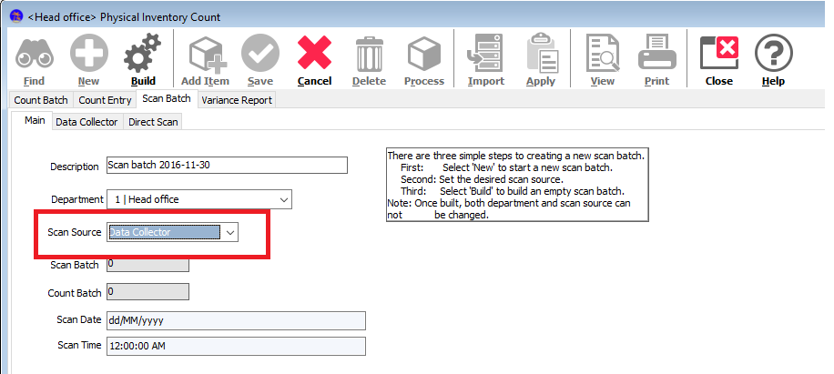

- Go to “IMPORT” button on the top menu
- Choose “Select Import Count List File”
- You should get the desired results as shown below

